**Blog 7**

**App Development Progress:-**

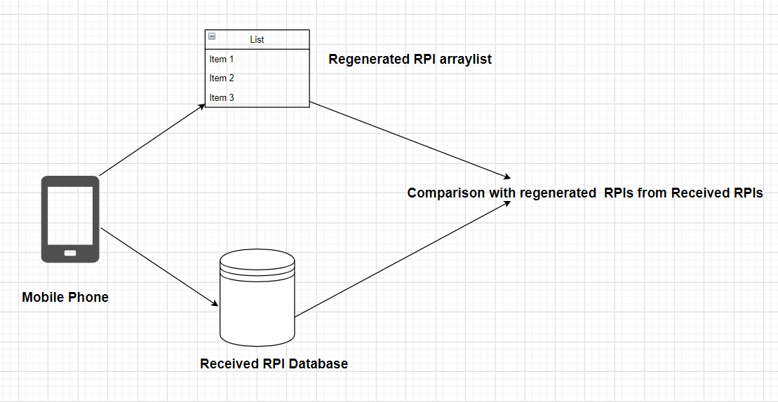

1. My work for the week was based on matching the received RPIs with RPIs generated from the downloaded TEKs.
2. I wrote the functions and queries to complete this process
3. Each time a TEK database is downloaded from the server, the app recreates the RPIs and compare it with the SQLite database of the phone.
4. If a match is found, the user was in contact with an infected person.

**Query-** Main query used to compare the entities of the arraylist and the received RPI table

@Query(**"SELECT count(*) FROM rpis where rpi in (:listOfRpis)"**)  
 Integer matchRPI(List<String> listOfRpis);  
}

**Function- public boolean** matchRPI(List<String> listOfRpis)  
{  
 Integer count= **mRPIDao**.matchRPI(listOfRpis);  
 **if**(count>0)  
 {  
 System.***out***.println(**"Match found in RPI table"**);  
 **return true**;  
 }  
 **else** {  
 System.***out***.println(**"Match not found in RPI table"**);  
 **return false**;  
 }  
}

This functions calculates the number of matches found and print a message for the user. In the final app, we plan to use a pop-up message for this.

1. **No match found- User is safe**

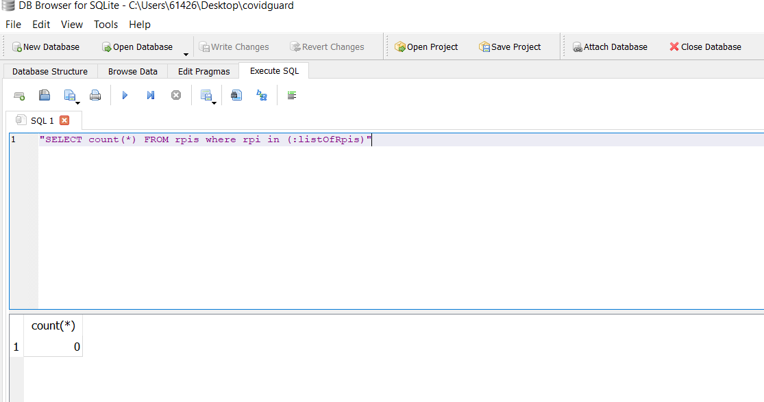

1. **Match found- User is unsafe**

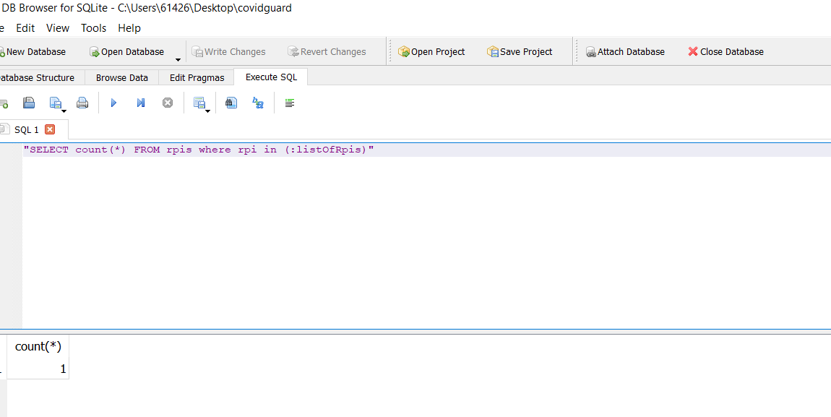

**Plan for this week-**

1. There is a “Self-Assessment Test” feature on the Aarogya Setu Application in which some questions related to the health and symptoms of the user are asked, and based on the answers, the application shows the risk level for the user in different color codes. There is no risk if it indicates green color code and the text shows “You are safe.” There is low risk if it shows yellow color code and the version shows “You are at moderate risk.” There are high chances of risk if it shows an orange color code; then the user must contact the help-line number given in the App. The application also suggests specific actions that can be taken to stop the spread of coronavirus, such as social distancing, taking care of hygiene, and staying at home as precautions.

I plan to implement this functionality in our app.